Dear Intern

Interim project report is an inherent component of your internship. We are enclosing a reference table of content for the interim project report.

The key objective of this report is for you to capture how far you have got in completing the internship work against milestones expected to be achieved within a specific duration and seek the mentor’s feedback. Depending on the internship project and your progress (IT/Non-IT, Technical/Business Domain), you may choose to include or exclude or rename sections or leave some sections blank from the table of content mentioned below. You can also add additional sections. You can refer the project presentation to view the milestones related to your internship project. Please populate milestone# (1 / 2 / 3) and the milestone description in the interim project report based on the milestone for which you are submitting the interim project report.

You can refer the project presentation to view the milestones related to your internship project.

|  |  |
| --- | --- |
| Internship Project Title | TCS iON RIO-125: Forecasting System - Project Demand of Products at a Retail Outlet Based on Historical Data. |
| Name of the Company | TCS iON |
| Name of the Industry Mentor | Sir Himalay Ashish |
| Name of the Institute | Symbiosis University of Applies Sciences |

|  |  |  |  |  |  |  |
| --- | --- | --- | --- | --- | --- | --- |
| Start Date | End Date | | Total Effort (hrs.) | | Project Environment | Tools used |
| 2/03/21 | 6/03/21 | | 6 | |  | Project Reference Material and webinar |
| Milestone # | 1 | Milestone: | | Student should be able to create a dataset, clean the dataset and also sanitize it. | | |

**TABLE OF CONTENT**

* Acknowledgements
* Objective
* Introduction / Description of Internship
* Internship Activities
* Approach / Methodology
* Assumptions
* Exceptions / Exclusions
* Charts, Table, Diagrams
* Algorithms
* Challenges & Opportunities
* Risk Vs Reward
* Reflections on the Internship
* Recommendations
* Outcome / Conclusion
* Enhancement Scope
* Link to code and executable file
* Research questions and responses

**INTERNSHIP PROGRAM 2021**

*ON*

***TCS iON RIO-125: Forecasting System - Project Demand of Products at a Retail Outlet Based on Historical Data.***

**TCS iON**

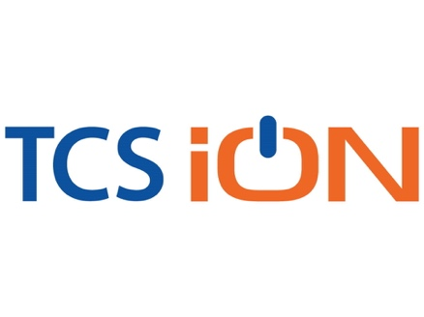

6th March 2021

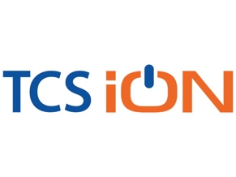

**ACKNOWLEGDEMENT**

The internship opportunity that I had with TCS iON was a great change for learning and understanding the intricacies of the subject of; and also, for personal as well as professional development. I am very obliged for having a chance to interact with so many professionals who guided me throughout the internship project and made it a great learning curve for me.

Firstly, I express my deepest gratitude and special thanks to the Training & Development Team of TCS iON who gave me an opportunity to carry out my internship at their esteemed organization. Also, I express my thanks to the team for making me understand the details of the Data Science and Analytics profile and training me in the same so that I can carry out the project properly and with maximum client satisfaction and also for spearing his valuable time in spite of his busy schedule.

I would also like to thank the team of TCS iON and my colleagues who made the working environment productive and very conducive.



**OBJECTIVE:**

***The objective of this project is to build a forecasting system to predict demand of a product based on historical data.***



**INTRODUCTION**

**What Is Demand Forecasting in Retail?**

**A Guide for Growing Businesses.**

Demand forecasting is a key component to every growing retail business. Without proper demand forecasting processes in place, it can be nearly impossible to have the right amount of stock on hand at any given time.

Too much merchandise in the warehouse means more capital tied up in inventory, and not enough could lead to out-of-stocks — and push customers to seek solutions from your competitors.

So, what is demand forecasting? And how is demand forecasting done in retail? Below, we’ll explain demand forecasting and how you can use it to support your retail business’ sustainable growth.

**Table of contents**

What is demand forecasting?

Why demand forecasting is important

Uses of demand forecasting

How is demand forecasting done?

Demand forecasting tips

How to calculate demand forecasting accuracy

**What is demand forecasting?**

Demand forecasting in retail is the act of [using data and insights](https://www.stitchlabs.com/blog/data-driven-retail-5-inventory-management-kpis-for-scalable-growth/) to predict how much of a specific product or service customers will want to purchase during a defined time period. This method of [predictive analytics](https://www.stitchlabs.com/press/stitch-labs-continues-automating-retail-launches-predictive-analytics/) helps retailers understand how much stock to have on hand at a given time.

### **What is demand forecasting in economics?**

Demand forecasting in economics is a bit different than how a retailer might use demand forecasting in business. So what do we mean by demand forecasting in economics, and how does that differ from retail?

In economics, analysts look at demand in the market as a whole, often for a particular industry or product category. In retail, you’ll look at the demand for YOUR products specifically. Demand forecasting in economics can (and should) inform forecasting in retail.

**What is demand forecasting in marketing?**

Demand forecasting in marketing is another component for retailers to consider. [Get your marketing and operations teams on the same page](https://www.stitchlabs.com/blog/marketing-and-operations-retail-success/) so that they can share calendars, priorities and initiatives and be proactive in planning. Retail ops can’t provide [inventory analytics](https://www.stitchlabs.com/retail-analytics-reporting/) for extra demand from a marketing campaign if they don’t know about it in the first place.

**Why demand forecasting is important?**

When explaining why demand forecasting is important, the answer spans across several areas of a retail business. One [Retail Systems Research report](https://www.sas.com/en_us/whitepapers/rsr-merchandising-omnichannel-impact-109055.html) found that nearly three-quarters of “winning” retailers rate demand forecasting technologies as “very important” to their business and their success.

**How does demand forecasting contribute to growing businesses?**

It mostly comes down to two things: becoming more cost-efficient and improving the customer experience.

How demand forecasting makes your business more cost-efficient

Almost every retail business is always looking for ways to cut costs. It’s one of the easiest ways to maximize your profits. When you implement a proper demand forecasting process to your business, you’re cutting costs in a few ways.

Firstly, you’re reducing the amount of capital you have tied up in unneeded inventory. And the less stock on hand you have, the lower your holding costs.

Secondly, you’re making sure you capitalize on every sale opportunity by not disappointing customers with out-of-stocks.

Those are the two most straightforward ways, but you can also use demand forecasting to operate a lean and agile business, only investing money in more stock when you need to. When you’ve forecasted demand, you can easily check in before the period’s over to see if you’re on target to hit your predicted sales. If you’re looking shy of your goal, you can [amp up marketing](https://www.stitchlabs.com/blog/growth-marketing-tactics-and-tips-for-retail-success/) and advertising. If it looks like you’ve underestimated, you could reorder or prep yourself to cross-promote a related product.

How demand forecasting enhances the customer experience

Another quick way to improve profits? Improve the customer experience. Rather than raising prices, focusing on the end user of the product can lead to customer loyalty and referrals.

Let’s go back to the most obvious: avoiding out-of-stocks that disappoint customers and lead them to your competitors. This is one of the most impactful ways to please customers.

Beyond simply having enough product to meet demand, you can also use forecasting to inform staffing decisions. While this is relevant to businesses needing [e commerce management](https://www.stitchlabs.com/integration-category/ecommerce-platforms/), it especially pertains to brick-and-mortar retailers. Customers who come to your store want to speak to an associate. And if no one’s there to help them, this can make a poor impression on shoppers. Even online sellers need to prep staff accordingly, especially during busy selling periods, so as not to delay [shipping and fulfillment](https://www.stitchlabs.com/resource/guides/simplifying-shipping-fulfillment/).

**Uses of demand forecasting**

As mentioned earlier, demand forecasting impacts many areas of your retail business. Here are just a few use cases of demand forecasting for rapidly growing businesses needing [multichannel management](https://www.stitchlabs.com/multichannel-inventory-management/):

* Prepare accurate budgets and financial planning
* Make informed purchasing decisions
* Implement [purchase order](https://www.stitchlabs.com/purchase-orders/) automations to avoid stock issues
* Gain a thorough, comprehensive understanding of your business
* Anticipate staffing needs
* Grow sustainably
* Measure progress towards business and sales objectives
* Streamline production process
* [Plan advertising and marketing campaigns](https://www.stitchlabs.com/resource/guides/developing-scalable-marketing-strategies/) and budgets
* [Enhance the customer experience](https://www.stitchlabs.com/resource/guides/creating-seamless-customer-experience/) (avoid out-of-stocks, backorders, late shipments, etc.)
* Resourcing and project management

**How is demand forecasting done, accurately?**

Rather than asking “how is demand forecasting done?”, retailers should ask “how is demand forecasting done*most accurately?*” There are many flaws to every approach to estimating demand and forecasting. Even though we can’t predict the future perfectly, using established methods can help you be more successful in your forecasting practices.

Demand forecasting is done most accurately when a business considers both internal and external [data](https://www.stitchlabs.com/blog/five-data-points-that-youre-missing-with-spreadsheets/). Internal metrics may include historical sales numbers, ad spend, and website or foot traffic. Externally speaking, you’re looking at factors like industry or consumer trends, the weather, and even your competitors.

To best explain demand forecasting, it’s helpful to look at the different methods. Some of the most common demand forecasting techniques include:

* Qualitative forecasting
* Time series analysis
* Causal model

**Qualitative forecasting**

This type of forecasting is when a business anticipates demand based on qualitative data. Qualitative data sources could include industry experts and/or consultants, employees, focus groups, and competitive analysis, to name a few. Often, this data is subjective and based on intuition rather than hard numbers or facts.

* Market research
* Delphi Method
* Expert opinion
* Focus groups
* Historical analogy
* Panel consensus
* Surveys

Recommended for: businesses that have limited historical data; new product launches (especially if there’s no other product like it on the market); instances where the previous period is believed to differ drastically from the planned period (for example, the [Tickle Me Elmo frenzy](https://www.timesunion.com/life/article/Remember-the-Tickle-Me-Elmo-craze-Hot-10781630.php) during the 1996 holiday season)

**Time series analysis**

The time series analysis is a more quantitative approach to demand and forecasting. Rather than expert opinions and “soft” data inputs, a time series analysis uses exact numbers as the basis for forecasting demand. It’s a more mathematical approach to forecasting which uses numerical inputs and trends.

Other quantitative forecasting methods include:

* The indicator approach
* Econometric modeling
* Trend analysis
* Seasonal adjustment
* Decomposition
* Graphical methods
* Life cycle modeling

Recommended for: retailers that have plenty of past sales data (especially if this data reveals year-over-year trends); seasonal items; [seasonal selling](https://www.stitchlabs.com/blog/turn-seasonal-shoppers-lifelong-brand-advocates/) periods; identifying cyclical sales trends

**Causal model**

The causal model accounts for demand forecasting factors that may change predicted demand. Demand forecasting factors are both controllable and uncontrollable:

|  |  |
| --- | --- |
| Controllable demand factors | Uncontrollable demand factors |
| Marketing, sales and promotions | Weather |
| Price | Politics |
| Visual merchandising | Trends |
| Location | Competitors |
|  | Economic and socioeconomic conditions |
|  | Seasonality |

Because the causal method of forecasting accounts for so many variables, it’s also a more complex approach. Some of the factors, like the weather, can’t be predicted as accurately as you might like. This includes a part guesswork, part data-driven approach to forecasting — and a lot of trust in your intuition.

Recommended for: data-driven retailers with lots of metrics; forecasting by specific product, category or SKU; retailers in volatile markets; multi-channel businesses with a diverse customer base; forecasting in association with marketing/advertising campaigns and promotions

Demand forecasting tips

Demand forecasting is half art, half science. The best approach is to account for qualitative and quantitative data, internal and external variables, and controllable and uncontrollable factors. Many assumptions must be made, as well as “guesstimations” based off your experiences.

That being said, there are a few tips for demand forecasting that you can apply to ensure you’re doing it properly:

Establish a baseline: This should be the first task on your list, aside from establishing a goal or hypothesis that you’ll want to achieve or answer with your forecast. Without having a baseline of data, you’re solely going off of third-party information.

Preserve your data: Because using your own data is so valuable in demand forecasting, you’ll also need to ensure the data is clean and accurate. [Centralize your inventory information](https://www.stitchlabs.com/why-centralized-inventory-management-is-the-key-to-profitability-in-an-omnichannel-world/) so that everything is synced and in a single location, and you’ll mitigate discrepancies.

Invest in the right tools: Without the right tools, demand forecasting can be a tedious, manual process. Find the right [inventory management software](https://www.stitchlabs.com/inventory-management-software/) that integrates with your accounting, point-of-sale and other tools for the most comprehensive look at your business.  
  
It’s not always clear [what to look for in an inventory system](https://www.stitchlabs.com/resource/ebooks/how-to-choose-inventory-management-software-for-retail-success/), so we created a guide to help.

**How to calculate demand forecasting accuracy**

It’d be remiss to explain demand forecasting without also describing how to calculate demand forecasting accuracy. After all, demand forecasting can be done by almost anyone — but it’s not always done accurately. And if your forecast is inaccurate, then you risk making majorly impactful business decisions based off the wrong information.

To calculate demand forecasting accuracy, many retailers look at the Mean Absolute Deviation (MAD) and Mean Absolute Percent Error (MAPE).

**MAD =**

MAD is the average difference between the actual demand and forecasted demand. To calculate MAD, you’ll subtract the forecasted demand from the actual demand. You can then average this number over several time periods to find out your overall MAD.

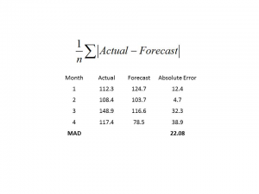

**MAPE =**

MAPE measures the rate of accuracy of your forecast and is calculated by subtracting the forecasted demand from the actual demand, and then dividing that number by the actual demand. To get the percentage, multiply by 100. Again, you’ll calculate this for multiple time periods and determine the average to find out your MAPE.

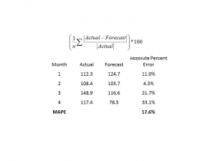

Business forecasting is essential for the survival for companies of all sizes. The building block used by forecasters is historical data or the past performance of the business to predict future results. Regression analysis is a statistical technique used to find relationships between independent and dependent variables. Regression analysis uses historical data and observation to predict future values.



**APPROACH**

**1. Created a dataset, cleaned the dataset and also sanitized it.**

* **Here is the screenshot of dataset, Superstore sales data.**

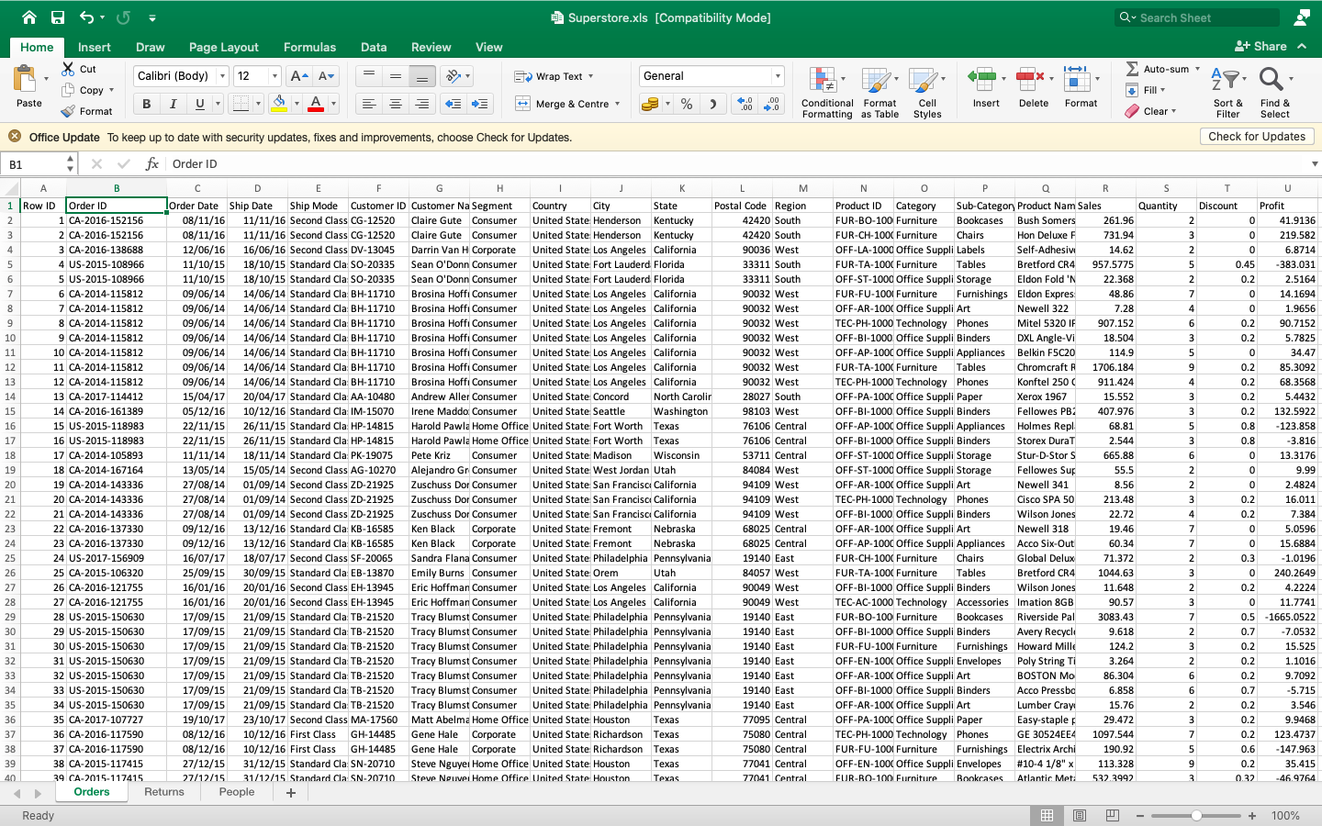

* **There are several categories in superstore sales data, we start from time series analysis and forecasting for furniture sales.**

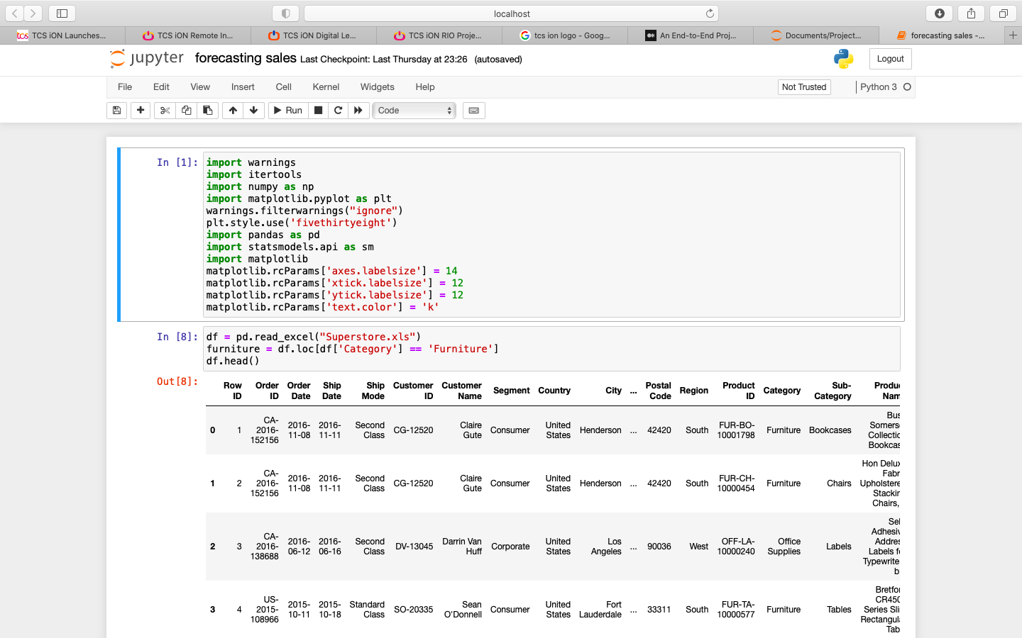

* **We have good 4-year sales furniture sales data.**

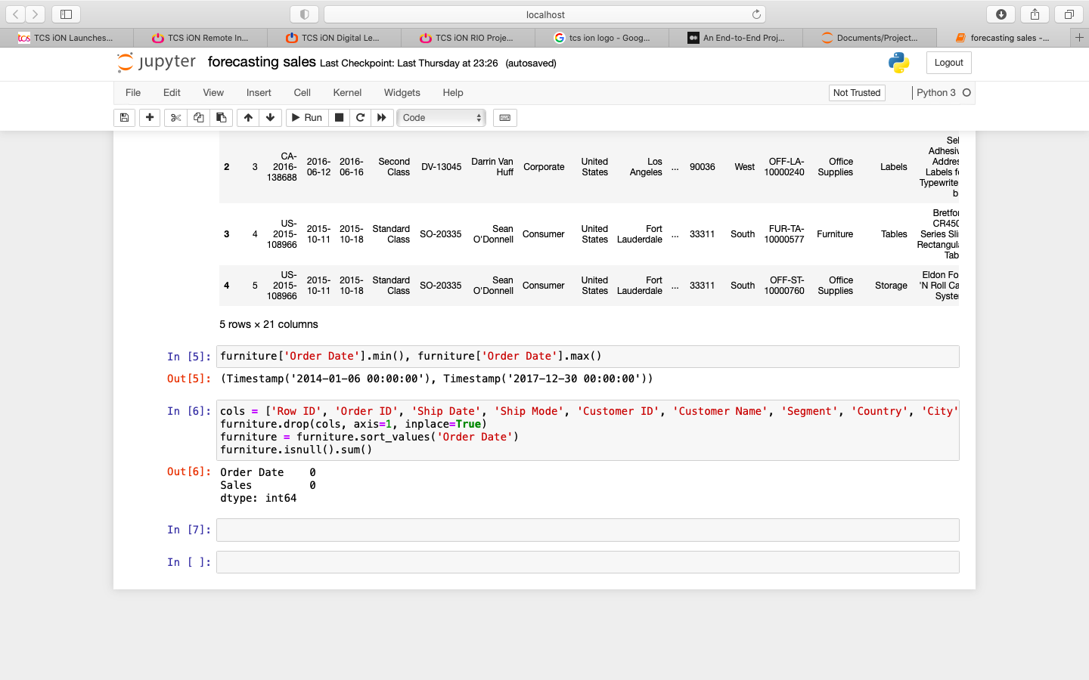

* **This step includes removing columns we do not need, check missing values, aggregate sales by date and so on.**



* **Indexing, our current datetime data can be tricky to work with, therefore, we will use the averages daily sales value for that month instead, and we are using the start of each month as the timestamp.**

